CCPOA
Annual Newsletter
It is hard to believe that another year has passed. Seems like only yesterday since the last time this annual newsletter was published. Hopefully, winter is behind us and spring is on the way. Public schools are closed for spring break which means children will be out and about enjoying time off from school. Please exercise extra caution as you drive our road system.
In December, a notice went out to property owners that CCPOA Board seats 3 and 5 would be up for election. Those seats were held by Larry Schroeder and Phil Rossi. They were unchallenged in the election and will return for another term. Congratulations to Phil who handles the Cape’s legal issues and will be serving his second term. Congratulations to Larry who manages the Cape’s maintenance and will be serving his fifth term.
With spring approaching, grass is sprouting up across the community. CCPOA has changed our contract mowing format. Instead of mowing once per month, beginning in March, contract mowing will occur twice per month. This change was made to improve the appearance of our community and to reduce the stress on the Cape’s mowing equipment.
Attached please find a collage of pictures including captions that show and describe drainage work improvements that were started several years ago, are ongoing, and will continue into the coming years. The outfall ditch improvements are complete with the exception of erosion control. Several options are being considered and evaluated for effectiveness and cost of installation. Many culvert pipe issues have been addressed, many more have been identified for remediation, and that work will continue as manpower is available. Several interior drainage ditches have been reprofiled to improve drainage to the outfall ditches. There is much more of this work to do. This is a long-term project that will progress as money and manpower is available. Most developed properties in the Cape have incorporated the drainage ditch in front of and along the side of our homes as part of our yards. Be advised that if drainage ditch remediation work is required in front of or alongside your property, by necessity it will include the removal of grass along with the dirt that must come out to improve drainage.
Condolences go out to Donald Beaver who has recently lost several family members including his mother and father.
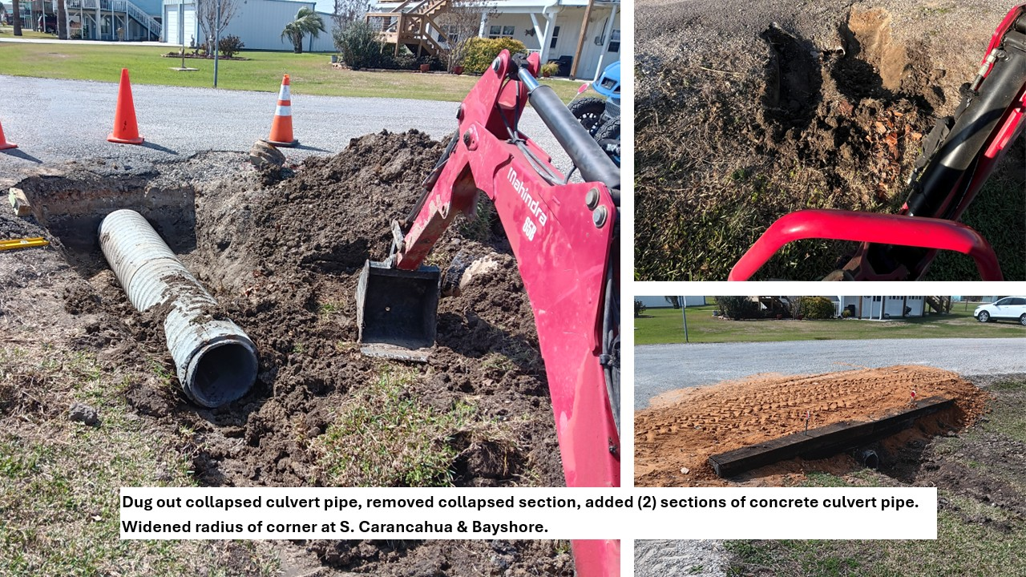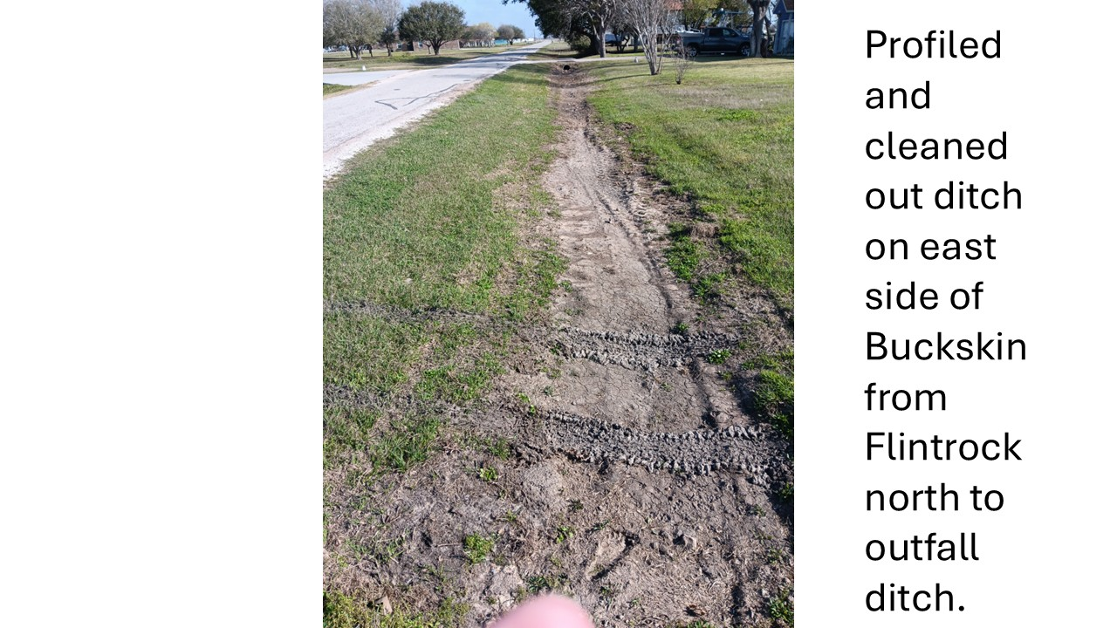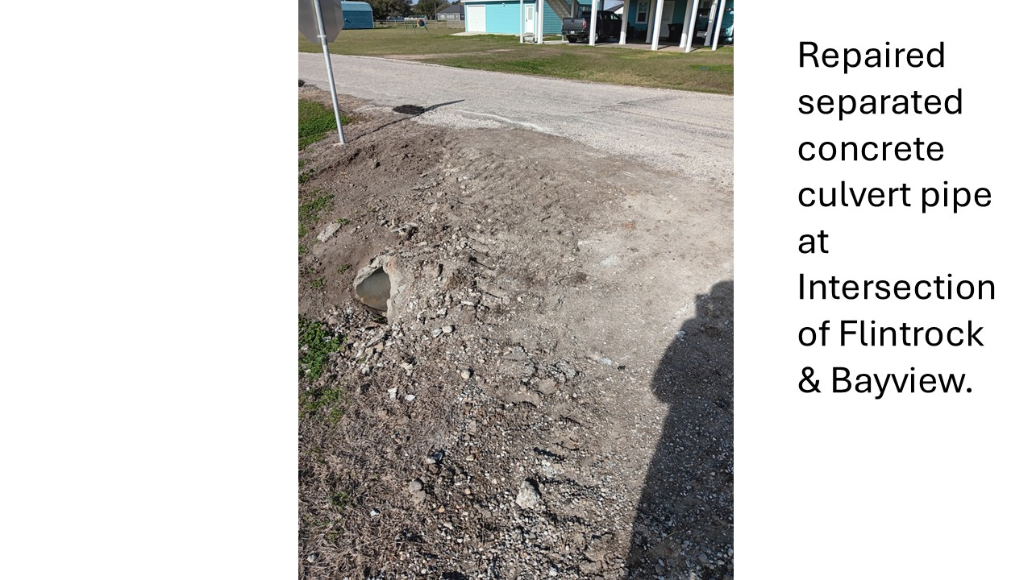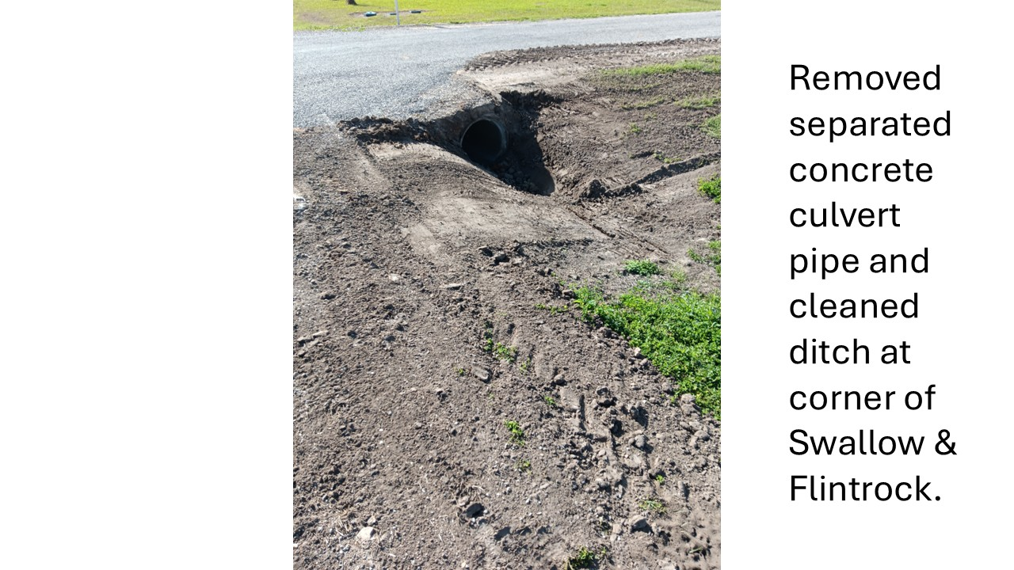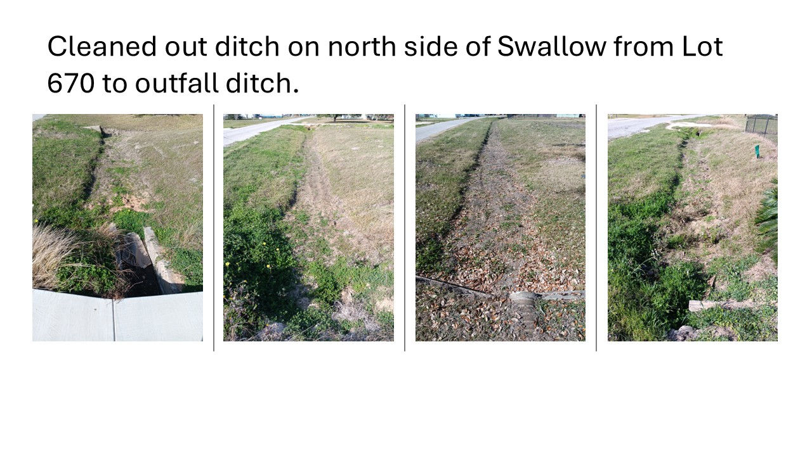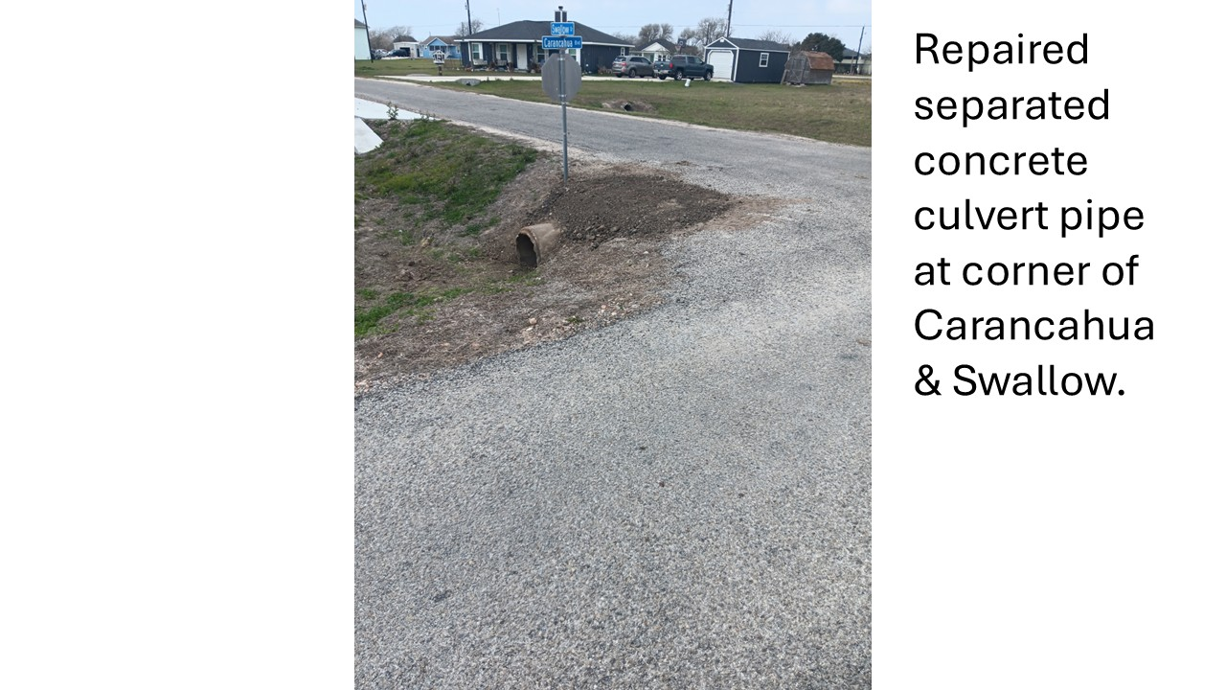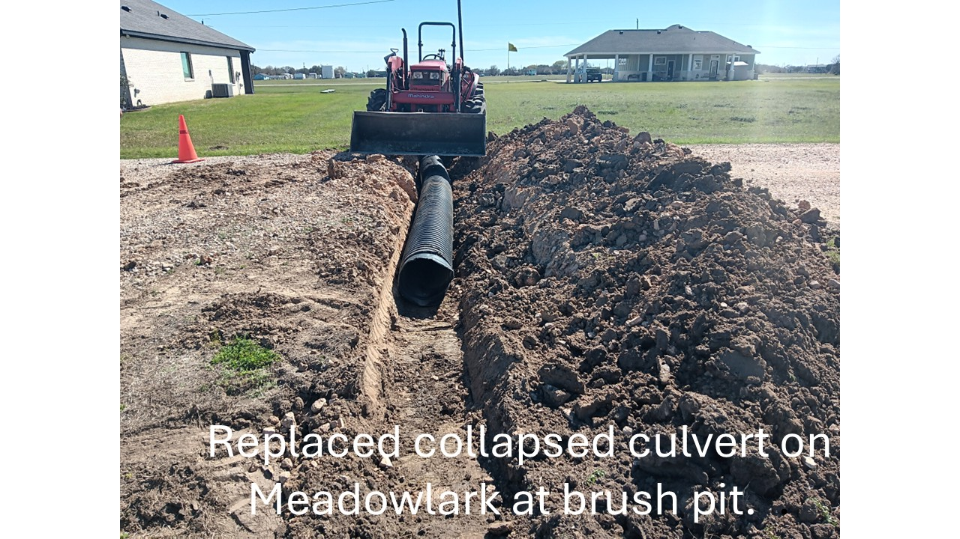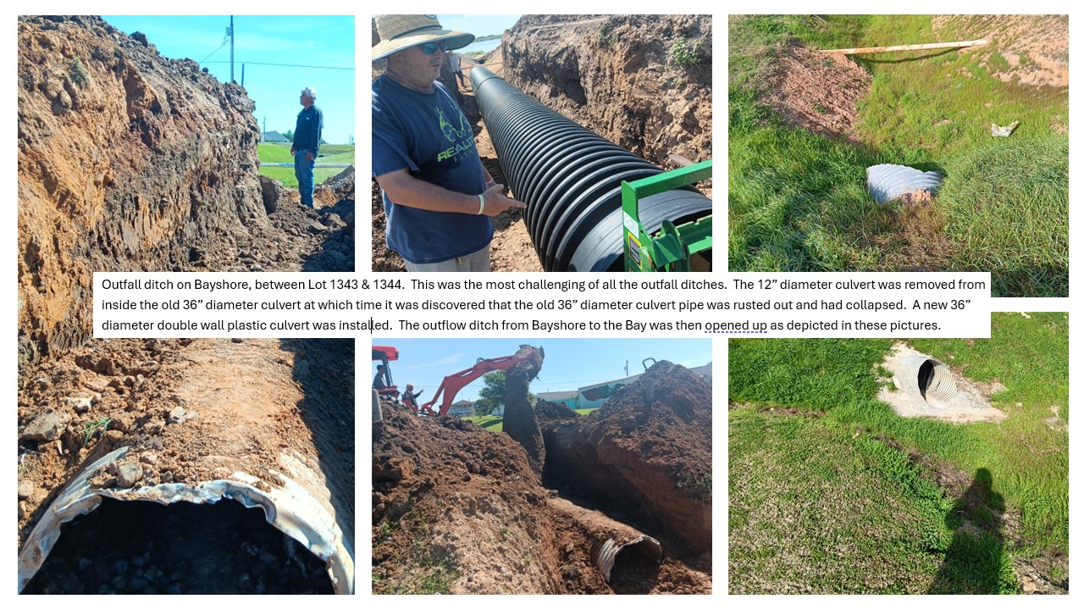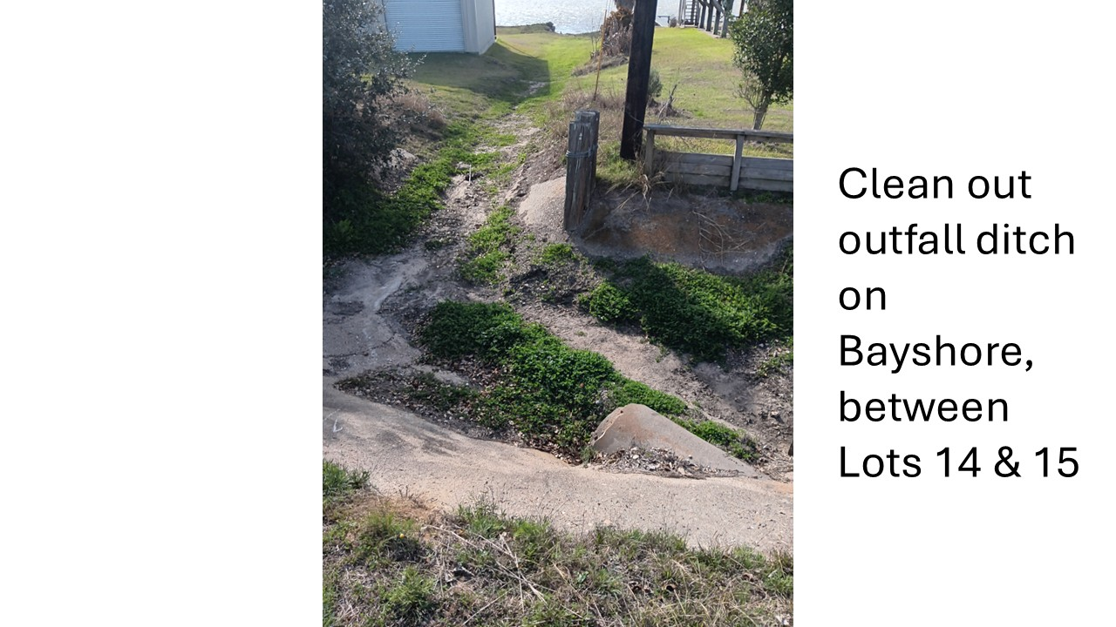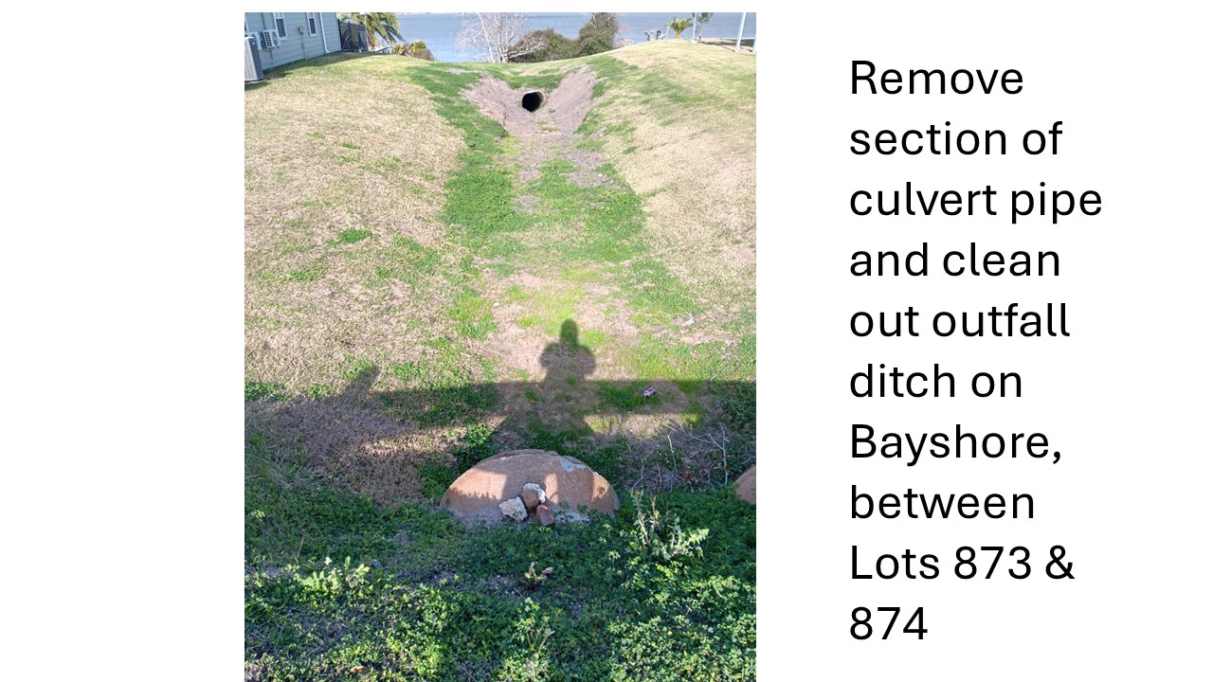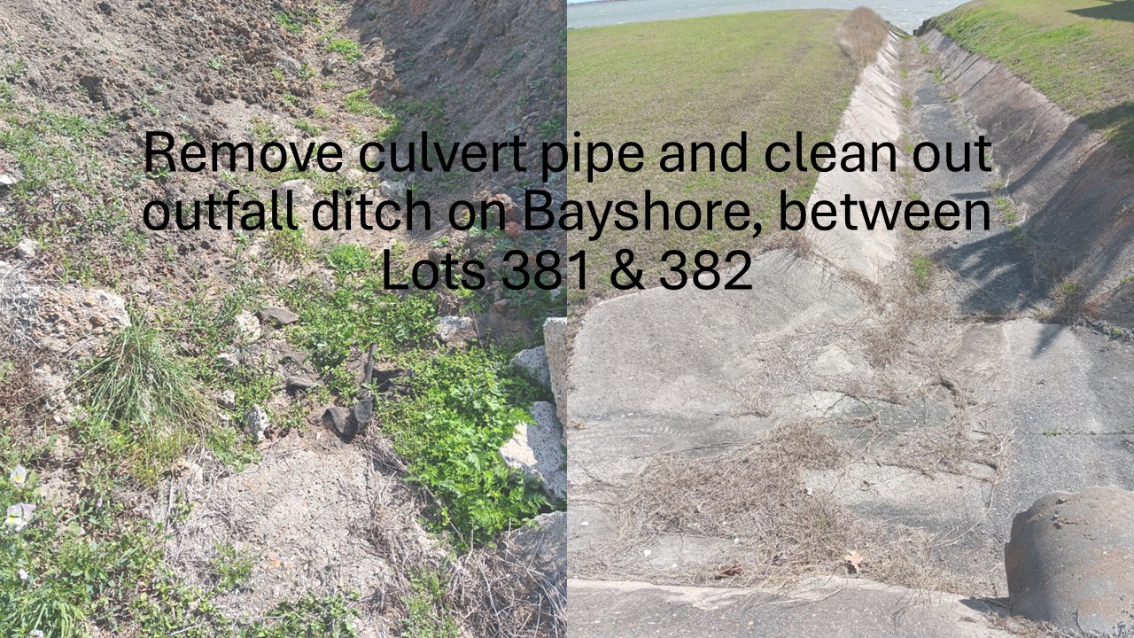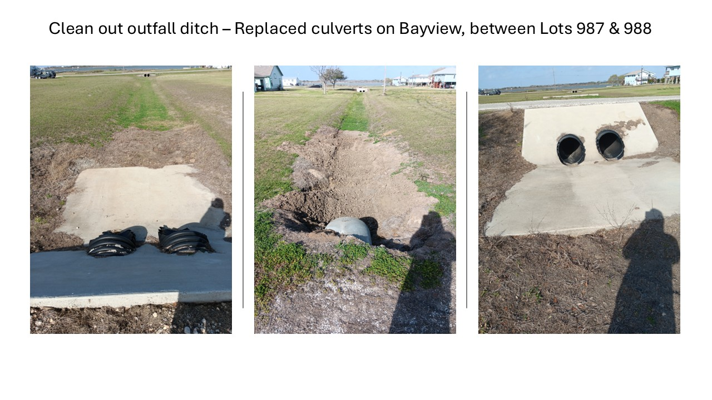
Carancahua Community Volunteer Fire Department
The last newsletter article was basically a plea for volunteers from the Cape, to join the Fire Department and use some time to help others in need. That was back in November of last year, and to date the total number of people even interested in joining is exactly zero. We’ve been very lucky indeed that we have had a number of new firefighters join up from Boca Chica and Deutchberg in the last two years to cover the needs of the Department. I understand that many (or all) of you have a spouse, children, a job (or two), or are just not able physically to do the job. So do we all. Here’s the straight situation. The area needs a Fire Department, because the nearest one in the County is too far, if you have a fire, or an accident, or a car wreck, or any of those things that we know will never happen to us, or our spouse, or our children. There is not enough tax money generated within ESD #2 which includes the Cape) to provide for a paid Department. With no new volunteers, the Fire Department will cease to exist. So, you might want to give some serious thought to volunteering. Who knows-the life you save might be someone you love. Call or text me at 713-569-4001 and we can talk about joining.
Thank you,
Craig Brooks, Chief
Caper Report
The Capers year is already in full swing.
In February, three new board members were elected:
Rae Jean Amy - President
Linda Teare – Vice President
Nancy Chambers – Treasurer
Charlotte Morgan remains as Secretary
We are preparing for the Annual Easter Egg Hunt, which will be held Saturday, April 4th at the Pavilion. The hunt begins at 10 am. Again, there will be a guessing game for the kids. They will sign up to guess the number of jelly beans in the jar. The winner gets the jar. Every child will get a decorated sugar cookie. There will also be a photo op for the smaller children in front of the Easter bunny. We are accepting cash donations and/or wrapped candy, drop it off at the office.
The Capers will sponsor the annual bake sale over Memorial weekend. The date is Saturday, May 23rd at the Community center. Sale begins at 10 am in the library. The goodies go quickly, so don’t be late!
Remember Capers collect aluminum cans and convert the cans into cash for our projects. Please consider bagging your CANS ONLY and leave them at either pool as there is a barrel at each pool for the collection. We will collect them.
We also collect pull tabs for the Ronald MacDonald House and wine corks that are taken to Spec’s.
We maintain a lending library in the community center. Everyone is welcome to come peruse the books and take some for reading. You do not have to return your selection.
We meet the second Monday of the month in the library inside the Community Center. Nour next meeting is Monday, March 9th at 10am in the library. Please come join us.
Rae Jean Amy

